**Ex.No. 1**

**DDL Commands – CREATE, ALTER, DROP**

1. Create a table name STUDENT with following structure

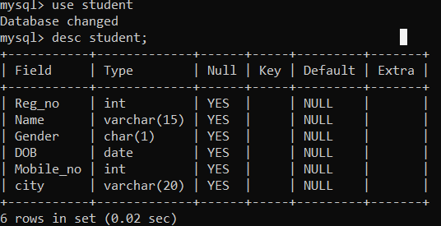

1. Create a table name FACULTY with following structure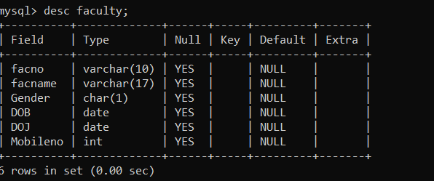

3)Create a table name DEPARTMENT with following structure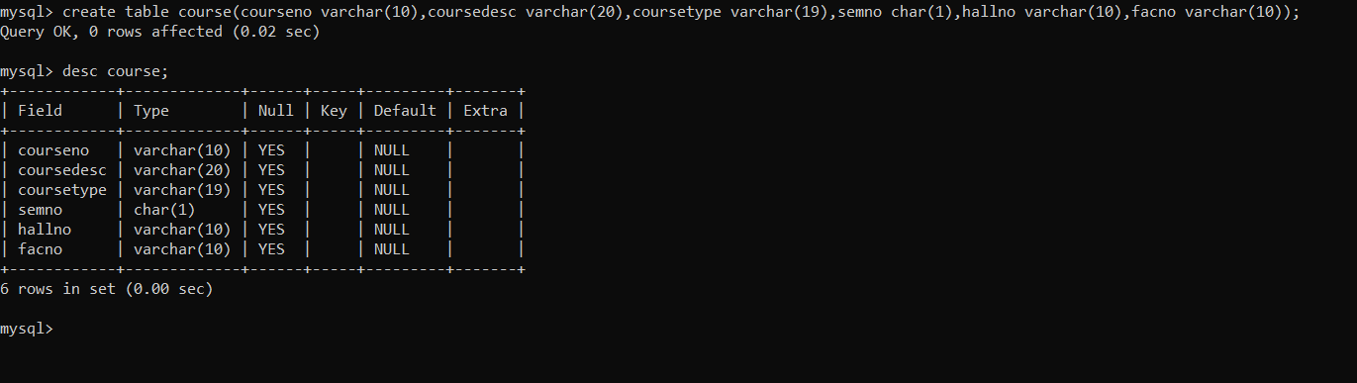

4) Create a table name COURSE with following structure.

5) Modify the table FACULTY by adding a column name DeptNo of datatype VARCHAR(4)